**ITIS 5166**

**Project 1 Website Prototyping**

Nikhil Reddy Muppidi

Id: 801263563

**Screenshots of the application pages:**

1. 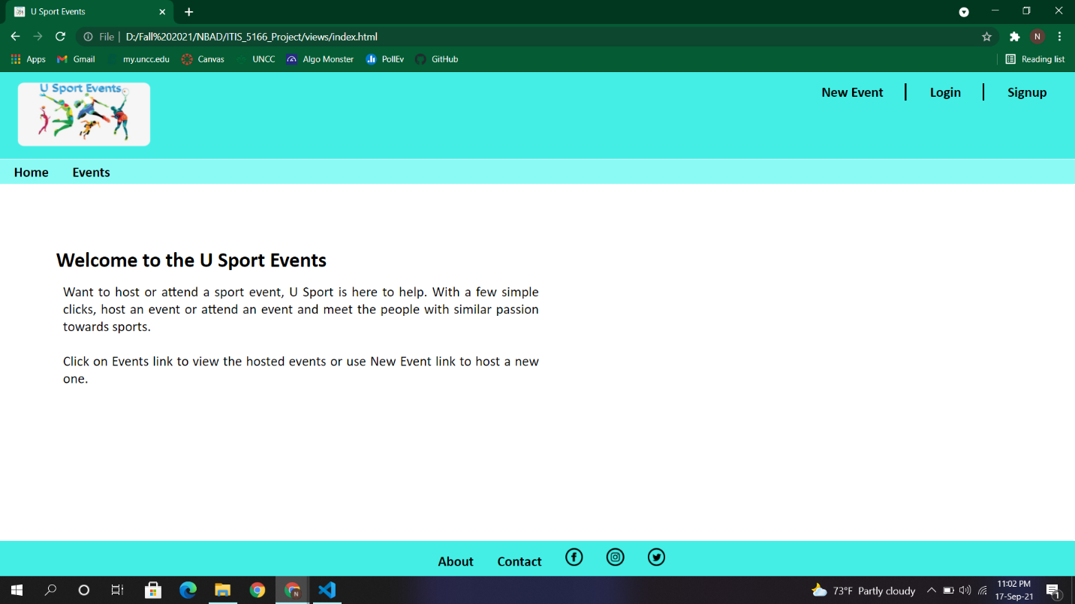Index.html (Home Page):
2. 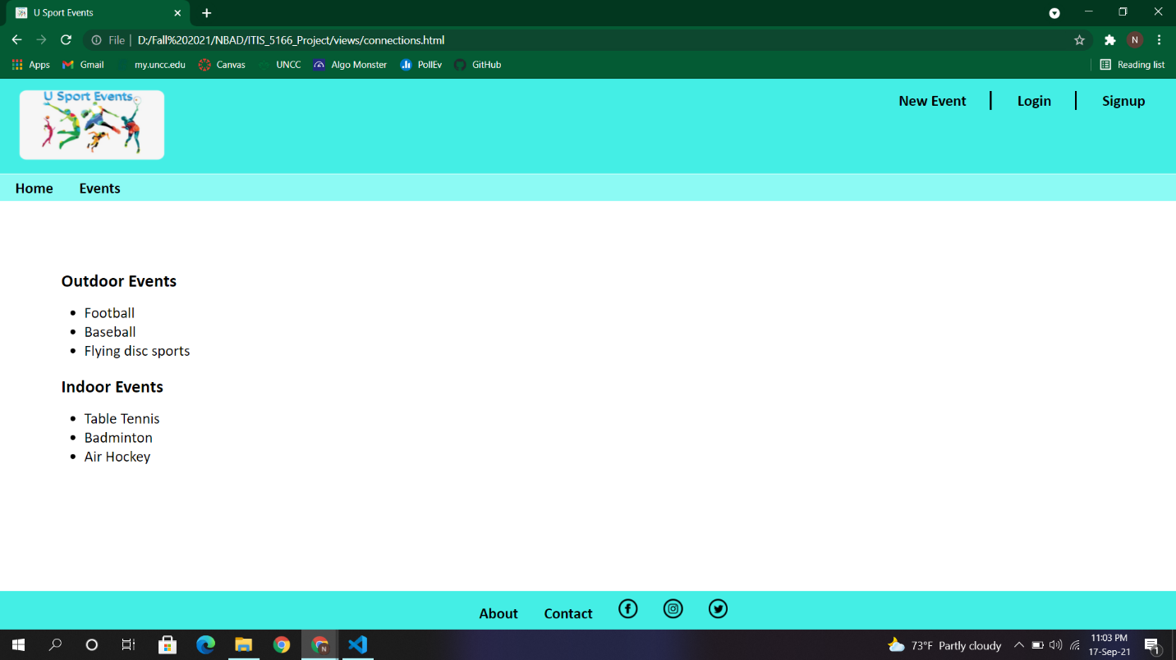Connections.html (List of hosted events):
3. 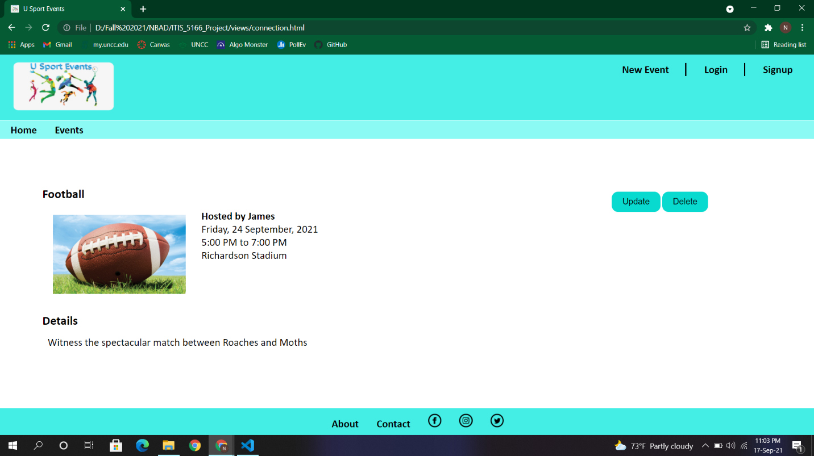Connection.html (Event details):
4. newConnection.html (Create new event):

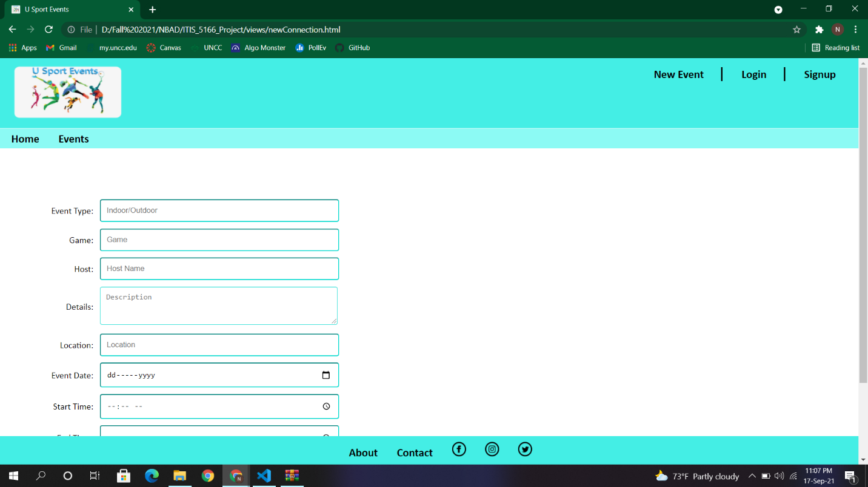

All the images used in the pages are stored in a separate directory named ‘Images’. Images directory and HTML pages are stored in ‘views’ directory.

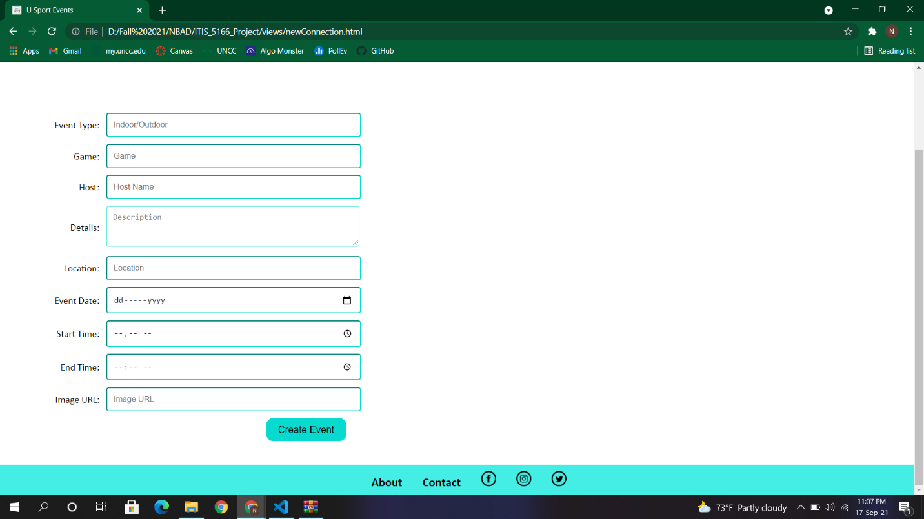The challenging part of the assignment was to add styling to the pages. I took help of many online resources to understand what are the styling attributes of an element and how these attributes effect each element.